Baldivis Secondary College


Semester Two Examination, 2017

Question/Answer booklet

MATHEMATICS

SOLUTIONS
SPECIALIST
UNITS 1 AND 2

Section Two:

Calculator-assumed

Student Number: In figures

In words

Your name

Time allowed for this section
Reading time before commencing work: ten minutes
Working time: one hundred minutes

Materials required/recommended for this section
To be provided by the supervisor
This Question/Answer booklet
Formula sheet (retained from Section One)

To be provided by the candidate
Standard items: pens (blue/black preferred), pencils (including coloured), sharpener, correction fluid/tape, eraser, ruler, highlighters

Special items: drawing instruments, templates, notes on two unfolded sheets of A4 paper, and up to three calculators approved for use in this examination

Important note to candidates
No other items may be taken into the examination room. It is your responsibility to ensure that you do not have any unauthorised material. If you have any unauthorised material with you, hand it to the supervisor before reading any further.

Structure of this paper

Section | Number of questions available | Number of questions to be answered | Working  time (minutes) | Marks available | Percentage of examination
Section One:  Calculator-free | 8 | 8 | 50 | 52 | 35
Section Two:  Calculator-assumed | 13 | 13 | 100 | 98 | 65
 |  |  |  | Total | 100

Instructions to candidates

1. The rules for the conduct of examinations are detailed in the school handbook. Sitting this examination implies that you agree to abide by these rules.

2. Write your answers in this Question/Answer booklet.

3. You must be careful to confine your response to the specific question asked and to follow any instructions that are specified to a particular question.

4. Additional working space pages at the end of this Question/Answer booklet are for planning or continuing an answer. If you use these pages, indicate at the original answer, the page number it is planned/continued on and write the question number being planned/continued on the additional working space page.

5. Show all your working clearly. Your working should be in sufficient detail to allow your answers to be checked readily and for marks to be awarded for reasoning. Incorrect answers given without supporting reasoning cannot be allocated any marks. For any question or part question worth more than two marks, valid working or justification is required to receive full marks. If you repeat any question, ensure that you cancel the answer you do not wish to have marked.

6. It is recommended that you do not use pencil, except in diagrams.

7. The Formula sheet is not to be handed in with your Question/Answer booklet.

Section Two: Calculator-assumed 65% (98 Marks)
This section has thirteen (13) questions. Answer all questions. Write your answers in the spaces provided.

Working time: 100 minutes.

Question 9 (6 marks)
(a) The point $P(-3, 5)$ is translated by the column vectors $\left[\begin{matrix}2 \\ -7\end{matrix}\right]$ and $\left[\begin{matrix}x \\ y\end{matrix}\right]$ to $P'(9, -11)$. Determine the values of the constants $x$ and $y$. (2 marks)
Solution
$$\left[\begin{matrix}-3 \\ 5\end{matrix}\right]+\left[\begin{matrix}2 \\ -7\end{matrix}\right]+\left[\begin{matrix}x \\ y\end{matrix}\right]=\left[\begin{matrix}9 \\ -11\end{matrix}\right]$$

$$\left[\begin{matrix}x \\ y\end{matrix}\right]=\left[\begin{matrix}9 \\ -11\end{matrix}\right]-\left[\begin{matrix}-3 \\ 5\end{matrix}\right]-\left[\begin{matrix}2 \\ -7\end{matrix}\right]$$

$$\left[\begin{matrix}x \\ y\end{matrix}\right]=\left[\begin{matrix}10 \\ -9\end{matrix}\right]$$

Specific behaviours
value of $x$
value of $y$

(b) Determine the single matrix that represents, in order, the composition of a rotation of $30°$ anti-clockwise about the origin followed by reflection in the line $y=x$. Express matrix coefficients in exact form. (4 marks)

Solution
$$\left[\begin{matrix}0 & 1 \\ 1 & 0\end{matrix}\right]×\left[\begin{matrix}\cos{30} & -\sin{30} \\ \sin{30} & \cos{30}\end{matrix}\right]=\left[\begin{matrix}\frac{1}{2} & \frac{\sqrt{3}}{2} \\ \frac{\sqrt{3}}{2} & -\frac{1}{2}\end{matrix}\right]$$

Specific behaviours
matrix for rotation
matrix for reflection
multiplies in correct order
correct matrix

Question 10 (6 marks)
An exam has two sections, A and B, containing 6 and 11 questions respectively.

Determine the number of different combinations of questions a candidate could choose if they must answer

(a) 3 questions from Section A and 2 questions from Section B. (2 marks)
Solution
$$\left(\begin{matrix}6 \\ 3\end{matrix}\right)\left(\begin{matrix}11 \\ 2\end{matrix}\right)=20×55 \\ =1100 \text{ways}$$

Specific behaviours
uses multiplication of combinations
correct number

(b) 4 questions, all chosen from the same section. (2 marks)
Solution
$$\left(\begin{matrix}6 \\ 0\end{matrix}\right)\left(\begin{matrix}11 \\ 4\end{matrix}\right)+\left(\begin{matrix}6 \\ 4\end{matrix}\right)\left(\begin{matrix}11 \\ 0\end{matrix}\right)=330+15 \\ =345 \text{ways}$$

Specific behaviours
uses addition of combinations
correct number

(c) 4 questions, with at least one question from each section. (2 marks)

Solution
$$\left(\begin{matrix}17 \\ 4\end{matrix}\right)=2380$$

$$2380-345=2 035 \text{ways}$$

Specific behaviours
calculates total ways, no restriction
subtracts answer from (b)

Question 11 (9 marks)
(a) If $p=4i-2j$ and $q=3i+2j$ determine

(i) the angle between the directions of $p$ and $q$, to the nearest tenth of a degree.
(2 marks)
Solution
$$\text{Using CAS angle is} 60.255≈60.3° \text{(1dp)}$$

Specific behaviours
states angle
rounds correctly

(ii) the scalar projection of $q$ on $p$. (2 marks)
Solution
$$\sqrt{3^{2}+2^{2}}×\cos\left(60.255\right)$$
$$≈1.79$$

Exact: $\frac{4\sqrt{5}}{5}$
Specific behaviours
expression for projection
states value

(b) The vector $21i+5aj$ has a magnitude of $29$ and is perpendicular to the vector $4i-2bj$. Determine the values of the constants a and b, where $a<b$. (5 marks)

Solution
$${21}^{2}+{(5a)}^{2}={29}^{2}$$
$$a=±4$$

$$\left(21\right)\left(4\right)+(5a)(-2b)=0$$
$$84-10(±4)b=0$$
$$b=±\frac{21}{10}$$

$$a=-4, b=-\frac{21}{10}$$

Specific behaviours
uses magnitude to form equation
calculate values of a
uses dot product to form equation
calculate values of b
chooses correct pairing

Question 12 (6 marks)
(a) A circle property says that if chords of a circle are of equal length then they subtend equal angles at the centre.

(i) Write the converse of this statement. (1 mark)
Solution
If chords of a circle subtend equal angles at the centre then they are of equal length.

Specific behaviours
writes converse

(ii) Draw a diagram to illustrate the converse statement and state whether the converse is also true. (2 marks)
Solution
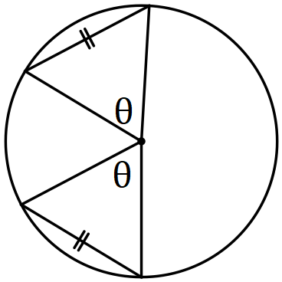Converse is true.
Specific behaviours
diagram
states converse true

(b) The diagram below shows four points $A$, $B$, $C$ and $D$ lying on the circumference of a circle. The line $PQ$ is a tangent to the circle at $A$, $∠BDC=21°$, $∠PAD=35°$ and $∠QAB=62°$.

Determine the size of angles $x$, $y$ and $z$. (3 marks)

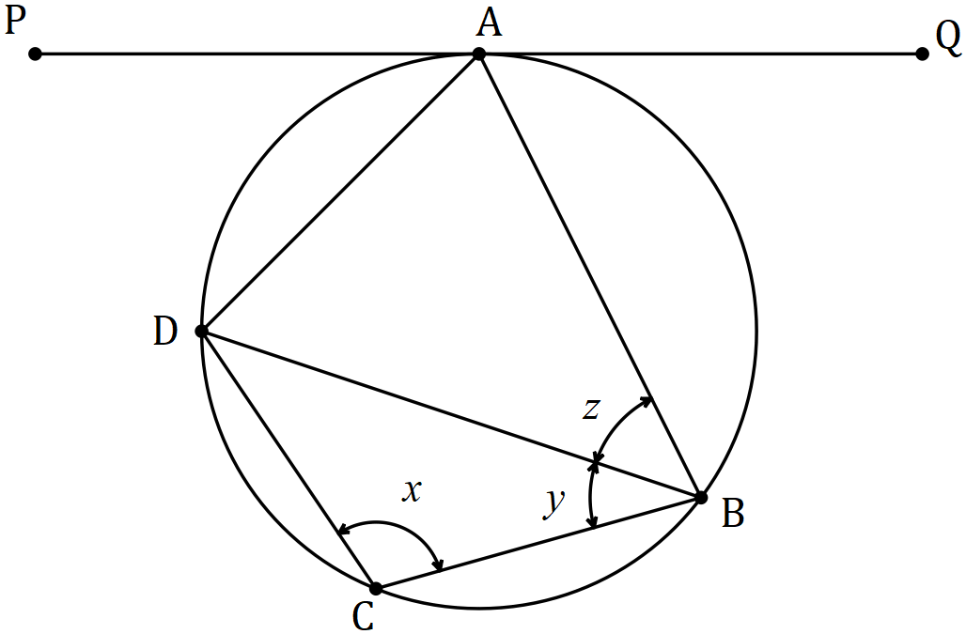
Solution
$$x=180-\left(180-35-62\right)=97°$$

$$y=180-97-21=62°$$

$$z=∠PAD=35°$$

Specific behaviours
each angle

Question 13 (8 marks)
In the diagram below, forces $F_{1}$ and $F_{2}$ act on a body at the origin.

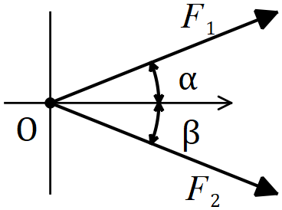

(a) If $F_{1}=85 N$, $F_{2}=105 N$, $α=21°$ and $β=35°$, determine the magnitude of the resultant force and the angle it makes with the positive $x$ axis. (5 marks)
Solution
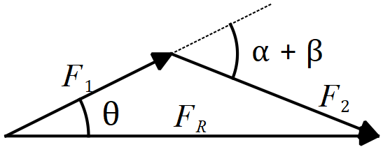

$$F_{R}=\sqrt{{85}^{2}+{105}^{2}-2\left(85\right)\left(105\right)\cos{124}} \\ F_{R}=168 N$$

$$\frac{\sin{θ}}{105}=\frac{\sin{124}}{168} \\ θ=31.2°$$

$$ϕ=21°-31.2°=-10.2°$$

Specific behaviours
sketch with forces nose to tail
uses cosine rule for magnitude
states magnitude
uses sine rule for angle
states angle with $x$ axis

(b) If $F_{1}=145 N$ and $F_{2}=180 N$, determine the angles $α$ and $β$ so that the resultant force is directed along the positive $x$ axis and has a magnitude of $310 N$. (3 marks)
Solution
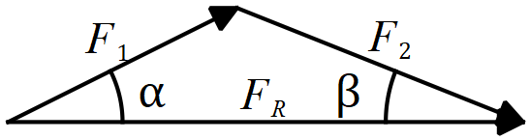

$$α=\cos^{-1}\left(\frac{{145}^{2}+{310}^{2}-{180}^{2}}{2\left(145\right)\left(310\right)}\right) \\ α=19.5°$$

$$β=\cos^{-1}\left(\frac{{180}^{2}+{310}^{2}-{145}^{2}}{2\left(180\right)\left(310\right)}\right) \\ β=15.6°$$

Specific behaviours
sketch with resultant on $x$ axis
uses cosine rule for angle
uses sine or cosine rule for second angle

Question 14 (6 marks)
(a) Prove that $\tan{3A}=\begin{matrix}3\tan{A}-\tan^{3}{A} \\ \overline{ 1-3\tan^{2}{A }} \end{matrix}$. (4 marks)
Solution
$$LHS=\tan{3A} \\ =\tan\left(A+2A\right) \\ =\frac{\tan{A}+\tan{2A}}{1-\tan{A}\tan{2A}} \\ =\left(\tan{A}+\frac{2\tan{A}}{1-\tan^{2}{A}}\right)÷\left(1-\frac{2\tan^{2}{A}}{1-\tan^{2}{A}}\right) \\ =\frac{\tan{A}-\tan^{3}{A}+2\tan{A}}{1-\tan^{2}{A}}×\frac{1-\tan^{2}{A}}{1-\tan^{2}{A}-2\tan^{2}{A}} \\ =\frac{3\tan{A}-\tan^{3}{A}}{1-3\tan^{2}{A}} \\ =RHS$$

Specific behaviours
expands sum of A and 2A
uses double angle identity for $\tan{2A}$
eliminates $1-\tan^{2}{A}$
simplifies

(b) Hence, or otherwise, solve $3\tan{A}-\tan^{3}{A}=1-3\tan^{2}{A}, 0≤A≤\frac{π}{6}$. (2 marks)

Solution
$$\tan{3A=1} \\ 3A=\frac{π}{4} \\ A=\frac{π}{12}$$

Specific behaviours
writes as $\tan{3A}=1$
solution

Question 15 (7 marks)
(a) Point $R$ lies on the circumference of a circle with diameter $PQ=51$ cm, so that $PR=4RQ$. Determine the exact length $RQ$. (3 marks)
Solution
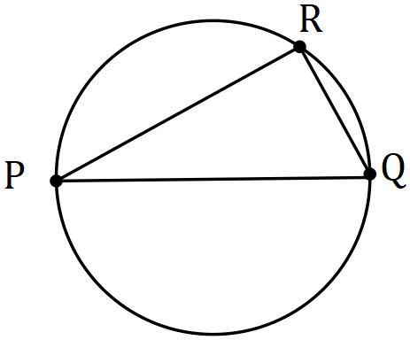

$$\text{Let} RQ=x, \text{then} x^{2}+(4{x)}^{2}={51}^{2}$$

$$x=3\sqrt{17} \text{cm}$$

Specific behaviours
diagram
uses Pythagoras' Theorem
states length

(b) Use a vector method to prove that the angle in a semi-circle is a right-angle. (4 marks)

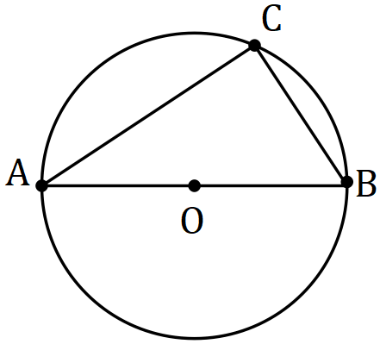

Let $\vec{OC}=c$ and $\vec{OB}=b$.
Solution
$$\vec{AC}=b+c \\ \vec{BC}=c-b \\ \vec{AC}∙\vec{BC}=\left(b+c\right)∙\left(c-b\right) \\ ={\left|c\right|}^{2}-{\left|b\right|}^{2} \\ =0, \text{as }\left|c\right|=\left|b\right|=\text{radius}$$

$$\text{Hence }∠ACB=90°$$

Specific behaviours
vectors for $AC$, $BC$
forms scalar product
simplifies scalar product, with reasons
concludes angle is right

Question 16 (10 marks)
(a) The graph of $y=\sin\left(a\left(x-b\right)\right)+c$ is shown below for $-π≤x≤π$.

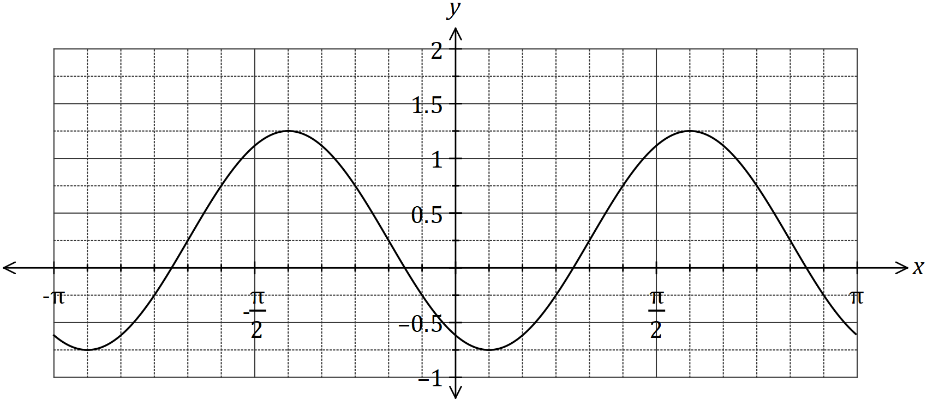

Determine the value of the positive constants $a$, $b$ and $c$. (3 marks)
Solution
$$a=2, b=\frac{π}{3}, c=\frac{1}{4}$$

Specific behaviours
value of $a$, value of b, value of $c$

(b) On the axes below, sketch the graph of $y=3\sec\left(x-\frac{π}{2}\right)$, $0≤x≤2π$. (3 marks)

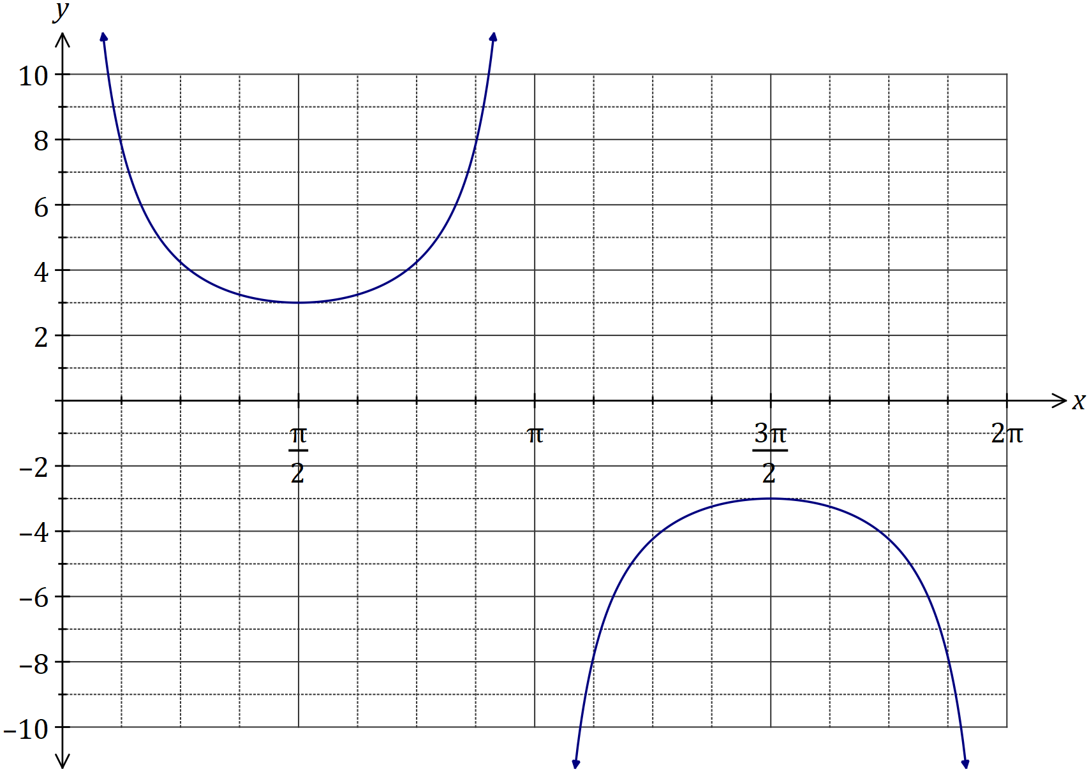
Solution
See graph
Specific behaviours
asymptotic behaviour
locations of max/min
smooth curve

(c) The displacement, $x$ cm, of a particle from a fixed point $O$ varies with time, $t$ seconds, according to the model $x=2\sin{(4πt)}+3\cos\left(4πt\right), t≥0$. Determine

(i) the initial displacement of the particle from $O$. (1 mark)
Solution
$$x=3$$

Specific behaviours
correct value

(ii) the exact amplitude of the motion. (1 mark)
Solution
$$A=\sqrt{2^{2}+3^{2}}=\sqrt{13} \text{cm}$$

Specific behaviours
correct value

(iii) the period of motion. (1 mark)
Solution
$$P=\frac{2π}{4π}=\frac{1}{2} \text{s}$$

Specific behaviours
correct value

(iv) the first time that the particle passes through $O$, rounded to two decimal places.
(1 mark)
Solution
$$t=0.17 \text{s}$$

Specific behaviours
correct value

Question 17 (7 marks)
(a) How many numbers must be chosen from the set of integers between 1 and 2017 inclusive to be certain that one of the numbers chosen is a multiple of 10. (3 marks)
Solution
201 multiples of 10 between 1 to 2017.

Require $2017-201=1816$ pigeonholes.

Hence must choose $1 817$ integers.

Specific behaviours
states # of multiples in set
one pigeonhole for every non-multiple
uses pigeonhole principle to add one

(b) A number is formed using four different digits chosen from those in the number 23 814. Determine how many different numbers can be formed that are

(i) even. (1 mark)
Solution
$$n\left(A\right)=3×4×3×2=72$$

Specific behaviours
states number

(ii) greater than 8 000. (1 mark)
Solution
$$n\left(B\right)=1×4×3×2=24$$

Specific behaviours
states number

(iii) even or greater than 8 000. (2 marks)
Solution
$$n\left(A∩B\right)=1×2×3×2=12$$
$$n\left(A∪B\right)=72+24-12=84$$

$$84 \text{numbers}$$

Specific behaviours
calculates number even and greater than 8 000
states number

Question 18 (9 marks)
Triangle $ABC$ has vertices $A\left(1, -2\right)$, $B\left(5, 2\right)$ and $C\left(4, -4\right)$.

(a) The vertices $ABC$ are transformed to $A^{'}B^{'}C^{'}$ using matrix $\left[\begin{matrix}1 & 0 \\ 0 & -1\end{matrix}\right]$. Write down the new coordinates of the vertices and describe the transformation. (4 marks)
Solution
$$\left[\begin{matrix}1 & 0 \\ 0 & -1\end{matrix}\right]\left[\begin{matrix}1 & 5 & 4 \\ -2 & 2 & -4\end{matrix}\right]=\left[\begin{matrix}1 & 5 & 4 \\ 2 & -2 & 4\end{matrix}\right]$$

$$A^{'}\left(1, 2\right), B^{'}\left(5, -2\right), C^{'}\left(4, 4\right)$$

Transformation is a reflection in the line $y=0$.

Specific behaviours
matrix product
writes as coordinates
states reflection
states equation of line of reflection

(b) The vertices $ABC$ are transformed to $A^{''}B''C''$ by matrix $M$ so that the new coordinates of the vertices are $A''\left(-6, -4\right)$, $B''\left(6, -20\right)$ and $C''\left(-12, -16\right)$.

(i) Determine the transformation matrix $M$. (3 marks)
Solution
$$M\left[\begin{matrix}1 & 5 \\ -2 & 2\end{matrix}\right]=\left[\begin{matrix}-6 & 6 \\ -4 & -20\end{matrix}\right]$$

$$M=\left[\begin{matrix}-6 & 6 \\ -4 & -20\end{matrix}\right]{\left[\begin{matrix}1 & 5 \\ -2 & 2\end{matrix}\right]}^{-1}$$

$$M=\left[\begin{matrix}0 & 3 \\ -4 & 0\end{matrix}\right]$$

Specific behaviours
writes matrix equation
uses inverse
determines $M$

(ii) If the area of triangle $ABC$ is $k$ square units, express the area of triangle $A''B''C''$ in terms of $k$. (2 marks)
Solution
$$\left|M\right|=12$$
$$\text{New area}=12k$$

Specific behaviours
determinant of $M$
expresses area

Question 19 (10 marks)
(a) Trapezium $OPQR$ has parallel sides $PQ$ and $OR$. $M$ is the midpoint of $OQ$ and $N$ lies on $QR$ so that $RN:NQ=4:1$.

Given that $\vec{OP}=p$, $\vec{OR}=r$ and $\vec{PQ}=3r$, determine the following in terms of $p$ and $r$.

(i) $\vec{OM}$. (2 marks)
Solution
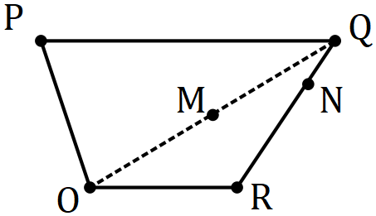

$$\vec{OM}=\frac{1}{2}\left(\vec{OP}+\vec{PQ}\right) \\ =\frac{1}{2}\left(p+3r\right) \\ =\frac{1}{2}p+\frac{3}{2}r$$

Specific behaviours
indicates half of $OP+PQ$
correct vector

(ii) $\vec{ON}$. (2 marks)
Solution
$$\vec{ON}=\vec{OR}+\frac{4}{5}\vec{RQ} \\ =\vec{OR}+\frac{4}{5}\left(\vec{RO}+\vec{OP}+\vec{PQ}\right) \\ =r+\frac{4}{5}\left(-r+p+3r\right) \\ =\frac{13}{5}r+\frac{4}{5}p$$

Specific behaviours
indicates $OR$ and four-fifths of $RQ$
correct vector

(iii) $\vec{NM}$. (2 marks)
Solution
$$\vec{NM}=\vec{OM}-\vec{ON} \\ =\left(\frac{1}{2}p+\frac{3}{2}r\right)-\left(\frac{13}{5}r+\frac{4}{5}p\right) \\ =-\frac{3}{10}p-\frac{11}{10}r$$

Specific behaviours
indicates difference of (i) and (ii)
correct vector

(b) Quadrilateral $OABC$ is shown below, where $P$, $Q$, $R$ and $S$ are the midpoints of the sides $OA$, $AB$, $BC$ and $OC$ respectively. Let $\vec{OP}=a$, $\vec{AQ}=b$ and $\vec{OS}=c$.

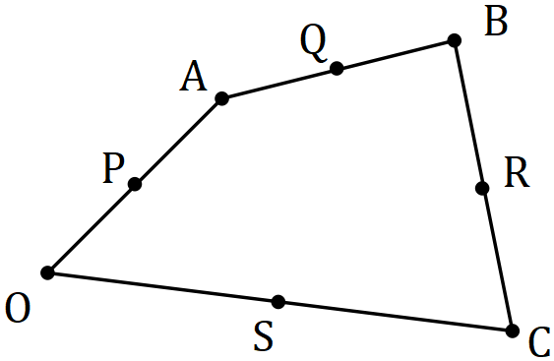

Show that $\vec{PQ}=\vec{SR}$. (4 marks)

Solution
$$\vec{PQ}=a+b$$

$$\vec{OR}=2a+2b+\frac{1}{2}\vec{BC} \\ =2a+2b+\frac{1}{2}\left(-2a-2b+2c\right) \\ =a+b+c$$

$$\vec{SR}=\vec{OR}-\vec{OS} \\ =a+b+c-c \\ =a+b \\ =\vec{PQ}$$

Specific behaviours
vector $\vec{PQ}$
vector $\frac{1}{2}\vec{BC}$
vector $\vec{OR}$
vector $\vec{SR}$

Question 20 (6 marks)
The diagram shows a semi-circle, with diameter $SR$ and centre $O$, circumscribed by triangle $ABC$, in which $∠BAC=44°$ and $∠ABC=102°$.

Determine, with reasons, the size of angles $∠QSO$ and $∠SPQ$.

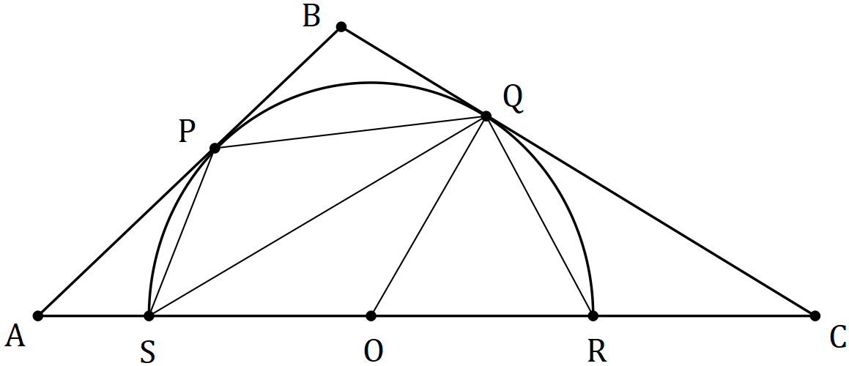

Solution
$$∠COQ=90-34=56° (∠CQO=90°, \text{tangent-radius})$$
$$∠QSO=56÷2=28° (\text{centre ∠=2×circumference ∠})$$

$$∠ORQ=\left(180-56\right)÷2=62 (∆OQR \text{isosceles})$$
$$∠SPQ=180-62=118° (PQRS \text{cyclic quadrilateral})$$

Specific behaviours
$∠COQ$
$∠QSO$
reasoning
$∠ORQ$
$∠SPQ$
reasoning

Question 21 (8 marks)
The sum of the first $n$ terms of the sequence $1+5+9+13+…+(4n-3)$ is $n(2n-1)$.

(a) Show that this statement is true when $n=6$. (2 marks)
Solution
$$LHS=1+5+9+13+17+21=66$$

$$RHS=6\left(2\left(6\right)-1\right)=6×11=66$$

$$\text{Hence statement true}$$

Specific behaviours
shows sum of terms for LHS
shows substitution in RHS and states true

(b) Use mathematical induction to prove the statement is true for $n∈Z ,n≥6$. (6 marks)

Solution
$\text{Assume statement true when} n=k$:

$$1+5+9+13+…+\left(4k-3\right)=k(2k-1)$$

$\text{When} n=k+1$:

$$1+5+9+13+…+\left(4k-3\right)+\left(4k-3+4\right)=k\left(2k-1\right)+\left(4k-3+4\right) \\ =2k^{2}+3k+1 \\ =\left(k+1\right)\left(2k+1\right) \\ =\left(k+1\right)\left(2\left(k+1\right)-1\right) \\ =n\left(2n-1\right)\text{ when} n=k+1$$

$$\text{The statement is true for }n=6 \text{ and by induction,}$$
$$\text{the truth when }n=k \text{implies the truth when }n=k+1$$
$$\text{and hence the statement is true for }n≥6.$$

Specific behaviours
assumed true for $n=k$
adds next term to both sides
simplifies RHS
factors k$+1$ out of RHS
indicates true for $n=k+1$
summary statement including truth of $n=6$

Additional working space

Question number: _________

Additional working space

Question number: _________

© 2017 WA Exam Papers. Baldivis Secondary College has a non-exclusive licence to copy and communicate this document for non-commercial, educational use within the school. No other copying, communication or use is permitted without the express written permission of WA Exam Papers. SN261-101-4.

